Project 2 READ ME file
Skylar Walker
12/12/2025
About the Project/Project Title
The goal of this project was to create a dashboard for Grazioso Salvare that had all the information on animals being tried for rescue.

Motivation
They needed a system that sorted thousands of different animals based on different features of the animals. Being able to sort based on hat breeds would be best for different rescue tasks.

Getting Started
To recreate this project, you first need a database that you are going to use to house all your information. My database was called aac_shelter. You also need to include some form of user so they have permission to use the database so the dashboard will load properly. You need to

Installation
I used python with the Jupyter lab IDE to develop my code. You also need to ensure you import the correct libraries, so the code functions without error. Both code from dash as well as plotly help with button presses on the dashboard as well as the creation of the pie chart.

Usage
Code Example:
These are the buttons I used for the dashboard as pseudo code:
If (button-one == pressed)
Filter data for wilderness rescue breed
Elif (button-two == pressed)
Filter data for disaster rescue dogs

Elif (button-three == pressed)
Filter data for water rescue dogs

Elif (button-four == pressed)
Show all animals in database

Screenshots:
The dashboard:
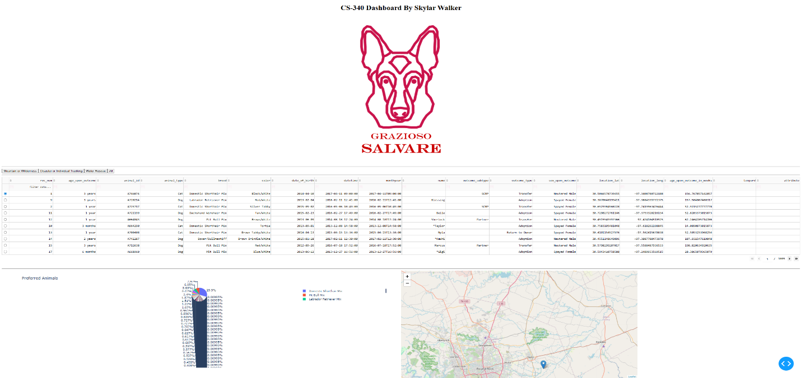

Mountain filter:
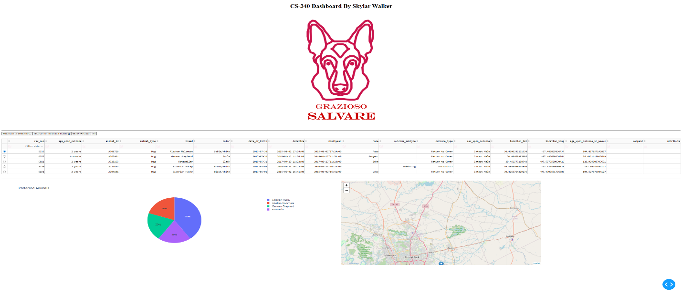
Disaster filter:
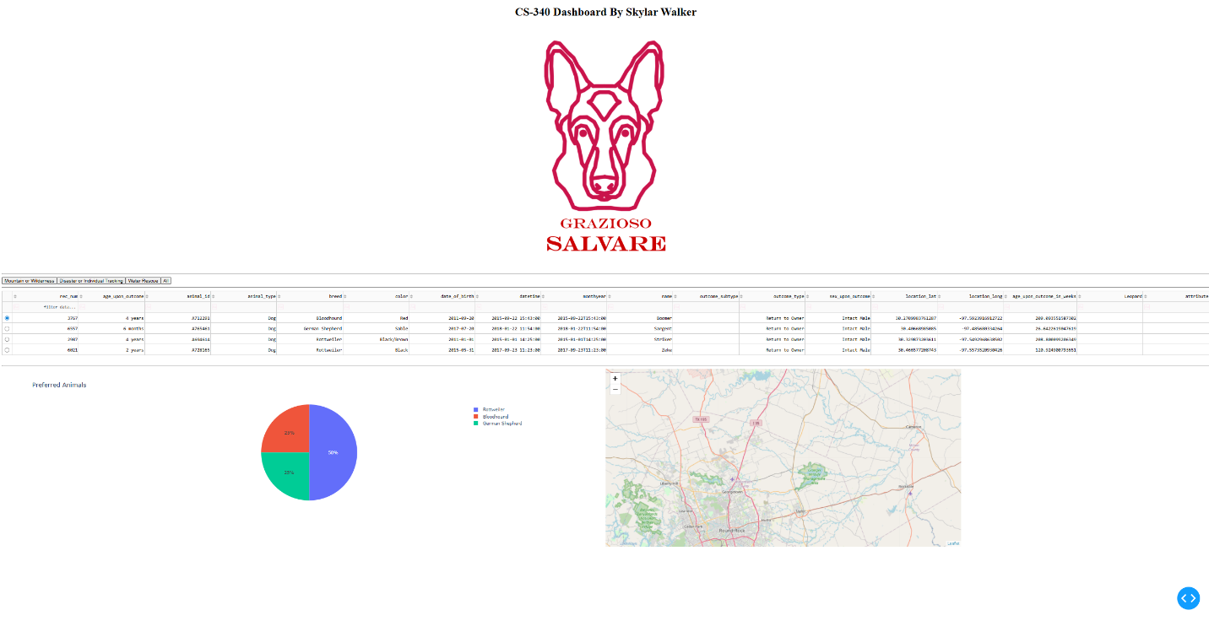
Water rescue:
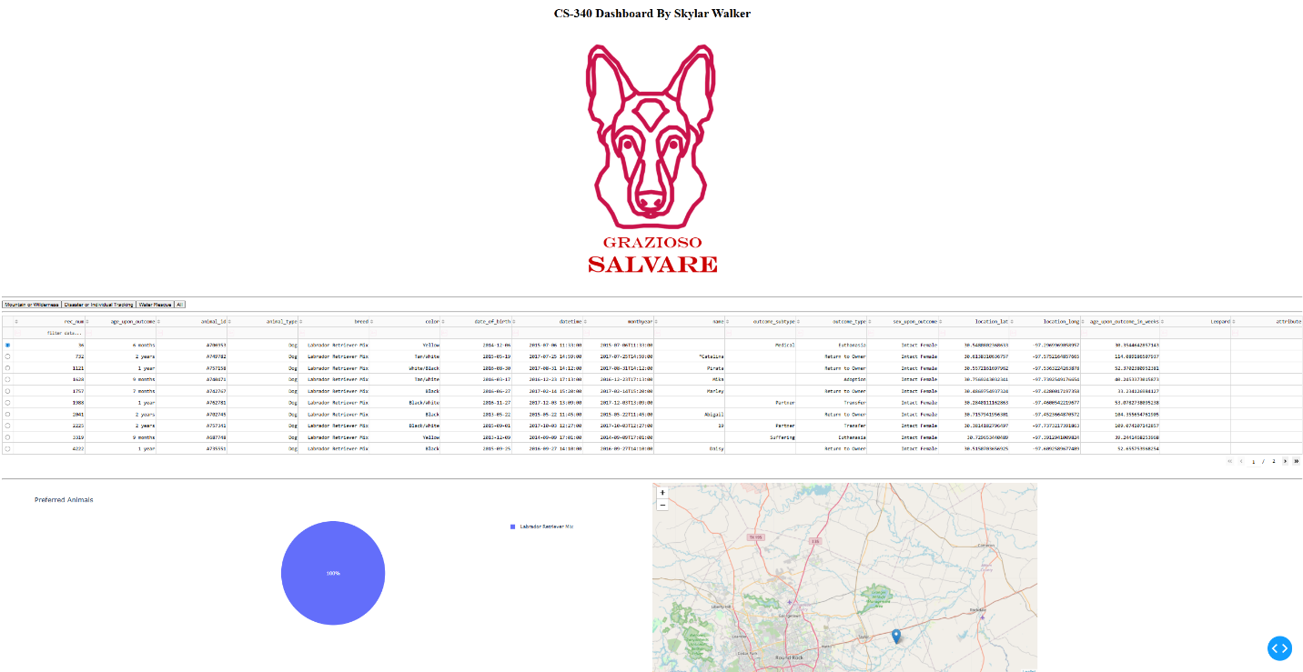

Button code:
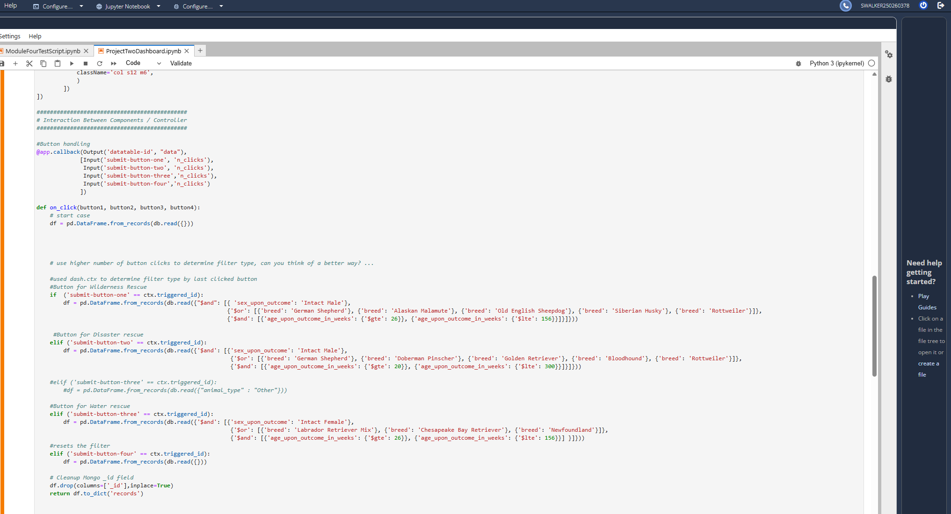
Pie chart:
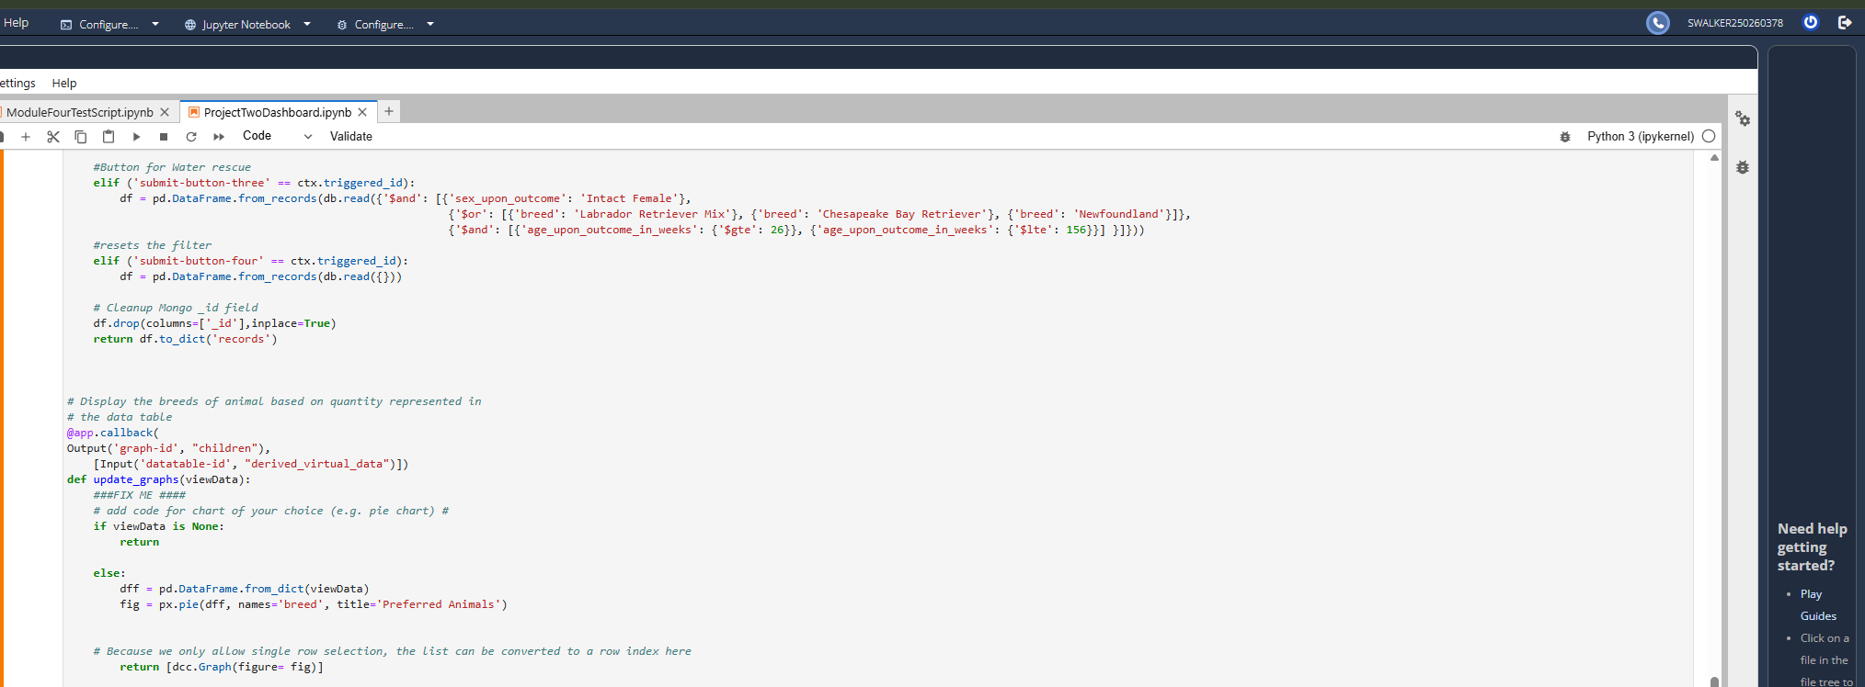

Contact:
Skylar Walker

